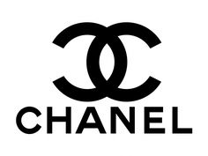
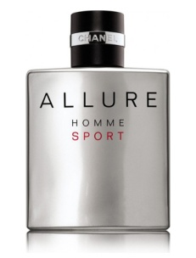
Unit 30 Task 2
Chanel Allure Homme Sport
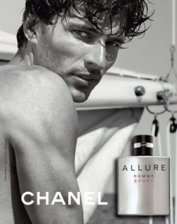
Research notes

- Original year of launch: 2004
With well known model Andres Valencoso Segura
The ad showed an athletic, sporty looking model
sailing

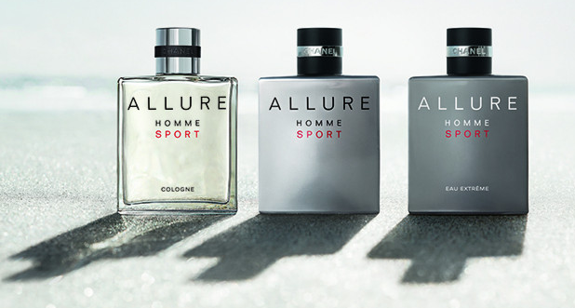
- The latest re-launch was in 2016 and this time Chanel decided to add cologne and
Eau Extreme to the range. The basic fragrance was the same for all three fragrances but with subtle differences.
The Cologne is lighter than the original and the Eau Extreme is sharper.

- For this new ad campaign Chanel hired well known fashion photographer Jacob Sutton to film the new faces of professional diver Hugo Parisi, professional skateboarder Adam Crigler and American actor, Luke Grimes. The ad was a great success and portrayed Chanel’s Allure Homme Sport as a must have fragrance for the active, sporty, athletic men of style.

- Target audience: Middle and upper middle class men aged 18 – 45 worldwide. So the demographic target audience is category A and B. Men who either already have or who aspire to have style and elegance

- Chanel Allure Homme was first launched in 1999 and portrayed a gentleman with style, class and sophistication. When Chanel Allure Homme Sport was launched 5 years later it used almost the same smell but it added ‘Neroli oil’ which comes from the Seville orange and this gave it more of a summery smell. When it was launched it still portrayed a gentleman with style, class and sophistication, but it added sporty and risk-taker to its campaign. So the audience could imagine it made them more free-spirited, faster and confident.

- Chanel Allure Homme Sport is made up of the following fragrance notes:
Top notes: Aldyhydes, Mandarin, Orange, Aquatic note
Heart notes: Black Pepper, Neroli, Cedar
Base Notes: Tonka, Vetiver, Amber, White Musk

- Chanel Allure Homme Sport range:
Cologne
Eau Exreme
Eau do Toilette refillable travel spray
After shave lotion
After shave moisturizer
Deodorant
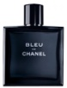
Hair and body wash
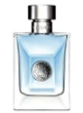
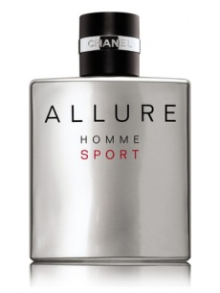
- The main competition for Chanel Allure Homme Sport is:
Blue De Chanel
Versace pour Homme
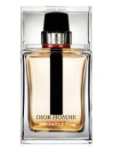
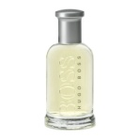
POLO sport – Ralph Lauren
Acqua Di Gio - Giorgio Armani
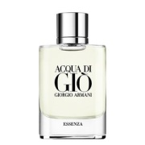
Homme Sport - Christian Dior
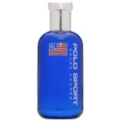
BOSS Bottled Sport

- Chanel is a well established perfume house with an excellent reputation for quality. It also sells haute couture, make up, jewellery, watches, fragrance and skincare.

- According to Credit Monkey ( https://www.creditdonkey.com/perfume-industry-statistics.html) in 2013 the perfume and fragrance industry worldwide was worth roughly $30 billion and it is estimated to increase to $45.6 billion by 2018.

- Celebrities such as Brad Pitt and Keira Knightly have all worked for Chanel to promote their perfumes and of course their fans then want to buy the perfume they are promoting.
